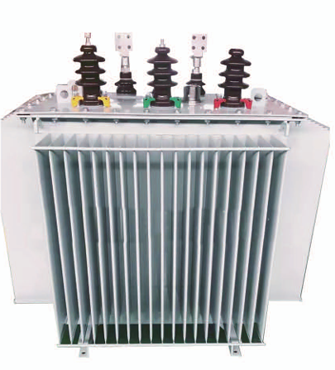
Power transformer

Main Functions and Features of S13 Power Transformer

1.Low Loss:
According to the current national standard GB/T20052-2020 Technical Parameters and Requirements for Three-Phase Oil-Immersed Power Transformers (30~1600kVA capacity):
S13-M.RL series: No-load loss reduced by 50% on average, load loss reduced by 30% on average.
S11-M.RL series: No-load loss reduced by 30% on average, load loss reduced by 25% on average.
2.Low No-Load Current:
Due to high-quality wound core materials and advanced winding processes, the no-load current is significantly reduced. Per GB/T20052-2020:
S13-M.RL series: No-load current reduced by 75% on average.
S11-M.RL series: No-load current reduced by 75% on average.
3.Low Operating Noise:
Compliant with the B/T10088-1999 noise standard. Both S13-M.RL and S11-M.RL series achieve 7–9 dB noise reduction.
4.Strong Short-Circuit Resistance:
The transformer body adopts a three-dimensional triangular structure, reinforced with tie rods on all sides. Integrated with upper/lower yoke insulation and laminated wood blocks, it effectively withstands axial and longitudinal mechanical stresses during sudden short circuits.

Performance Parameters of S13 Power Transformer

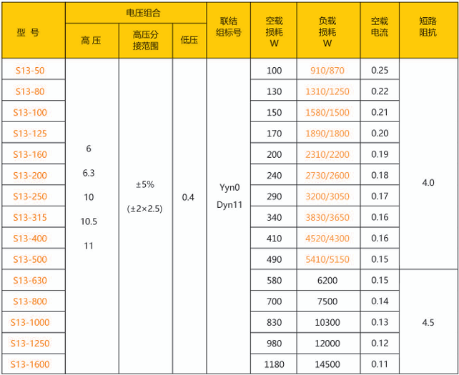

Advanced Production Equipment
GNEE Steel Group owns a full set of shearing, packaging, vacuum casting, vacuum impregnation, and testing stations that represent the high level of the industry. These top-notch production and testing equipment guarantee the creation of first-class products. The company continuously improves its design methods, achieving the most advanced computer-aided design to meticulously craft perfect products.

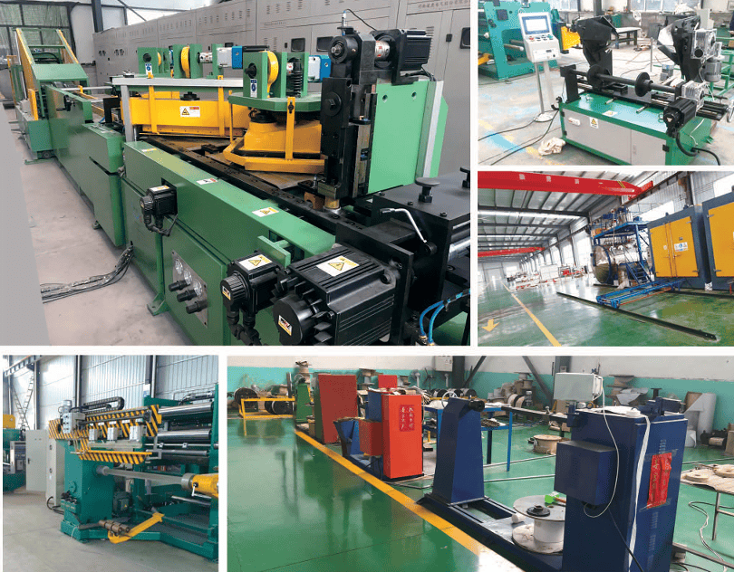

Production Environment
The workshop of GNEE Steel Group has strict process management and a closed management system. Regular purification and dust removal tests are conducted to meet the necessary requirements for producing high and low voltage transmission products. It has also passed ISO9001 quality certification and third-party inspection certification for international bidding.
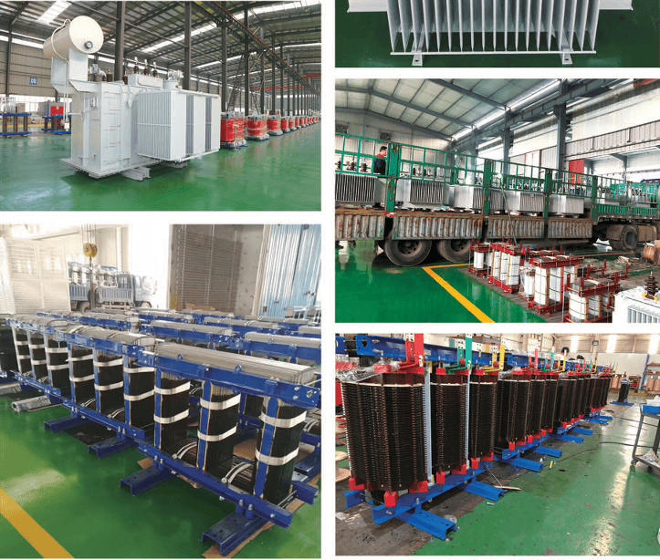
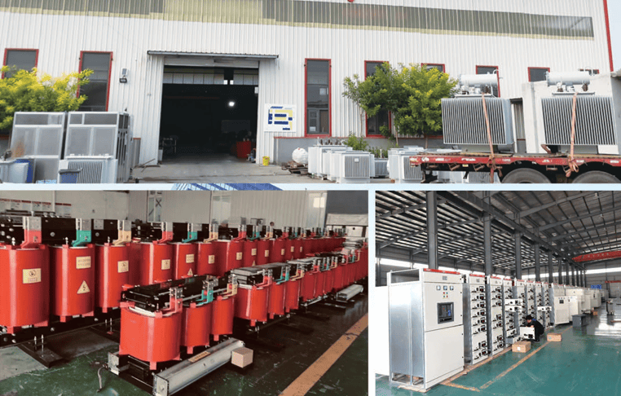

Autonomous Raw Material Supply
The iron cores and electromagnetic wires used in our company's products are all produced independently, which allows better control over the quality and delivery time of raw materials while reducing product costs.

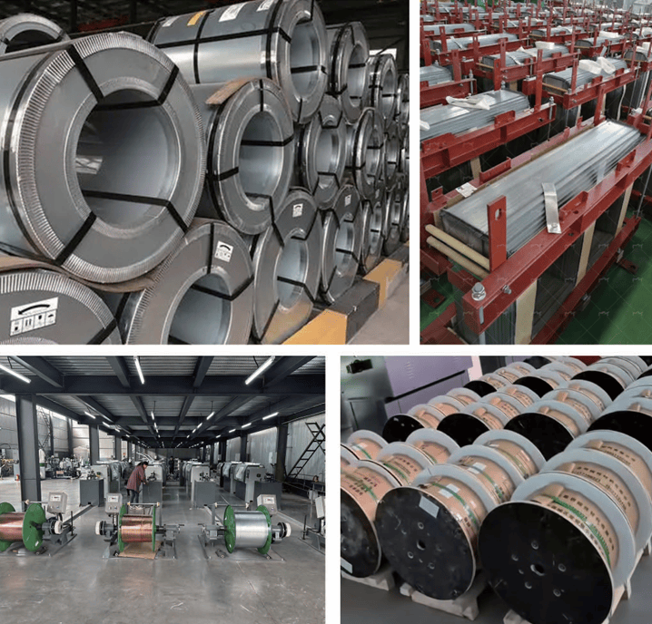

Raw Material Production Environment

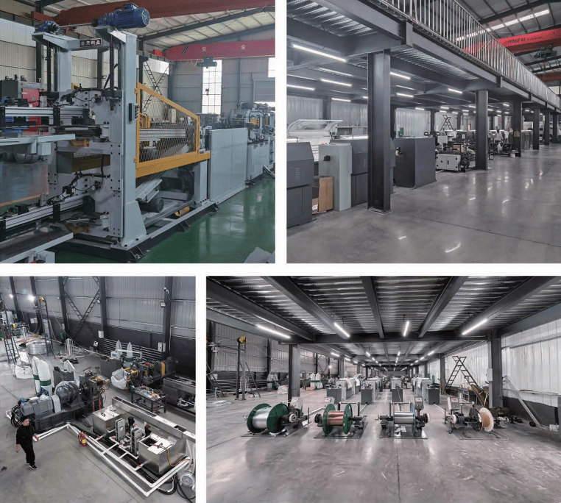

INTIMATE COMMUNICATION
Pre-sale, during-sale, and after-sale, we are with you every step of the way.
As long as you get in touch with us, we will communicate with you sincerely. Pre-sale, we will provide you with relevant product information; if you have special requirements, we can develop according to your needs and propose solutions under mutual recognition; during-sale, we will keep in touch with you throughout the process and inform you of the production progress, strictly following all the requirements in the contract; after-sale, our comprehensive "three guarantees" service system will ensure that you use our products with comfort, confidence, and satisfaction.
Inspection, Training, Guidance - All Free Of Charge.
As long as you are interested in our products and get in touch with us, we will take the initiative to contact you and arrange free inspections and factory experiences. We can also dispatch technical personnel to provide you with a free customized overall solution. Before the implementation of the solution, we will offer free training for your technical staff to inform them of the relevant knowledge about installation, commissioning, and maintenance of the product. During the equipment installation process, we will also provide you with free installation guidance. As long as it is your requirement, it is our mission; we will provide you with perfect services throughout the entire process.

Power Supply System Solutions Equipment Provider

Real Estate Development
In real estate development, container substations are widely used. In addition to short construction periods, low investment, small land occupation, and a new and beautiful appearance, the greatest advantage of this transformer is that it is installed in a moisture-proof, anti-corrosion, dust-proof, fire-proof, theft-proof, heat-insulating, fully enclosed, and mobile steel structure box. It integrates electromechanical equipment and runs fully enclosed, ensuring safety and long-term usability.

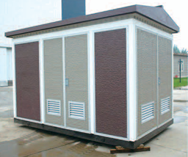
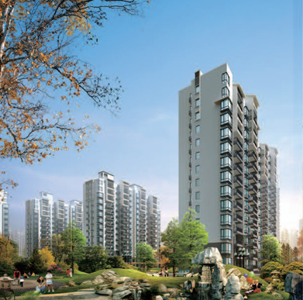

Industrial Enterprises
The fully sealed oil-immersed power transformer has the advantages of low loss, low noise, and high efficiency, which can achieve good energy-saving effects and reduce pollution. Compared with ordinary oil-immersed transformers, fully sealed transformers eliminate the need for an oil reservoir, and the changes in oil volume are automatically compensated by the elasticity of the corrugated oil tank's corrugated plates. The transformer is isolated from the air, preventing and slowing down the aging of oil and insulation, enhancing operational reliability, and requiring no maintenance during normal operation. Epoxy resin cast dry-type transformers can be used as updated replacement products for oil-immersed distribution transformers and are the best-performing products among various two-type transformers. They are particularly suitable for urban grids, high-rise buildings, business centers, theaters, hospitals, hotels, tunnels, subways, underground stations, laboratories, stations, docks, airports, combined substations, and other important places.
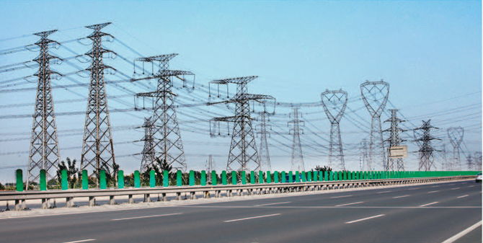

Oil Fields and Mines
High-efficiency energy-saving adjustable capacity transformers are designed based on the working characteristics of oil field pumping units. When the pumping unit starts, the transformer's output voltage is the rated input voltage of the motor, ensuring that the pumping unit has sufficient starting torque. After the pumping unit starts and enters the normal state, the control system will detect the size of the effective power consumed by the motor through sensors and feed it back to the microcomputer intelligent control system. Through calculations, it automatically adjusts the output voltage and capacity of the transformer, then detects, records, and compares the effective power consumed by the motor on the pumping unit, eventually finding the operating point where the consumption of effective power is minimal, achieving the purpose of energy saving. In terms of structural design, strong anti-theft measures have been taken, effectively preventing the theft of high-efficiency energy-saving transformers. At the same time, during the energy-saving operation of the pumping unit, according to the set anti-electricity theft time method, the output voltage fluctuates, making it impossible for home appliances to function even if the electricity is stolen back. Therefore, the transformer has high-performance anti-theft functions.
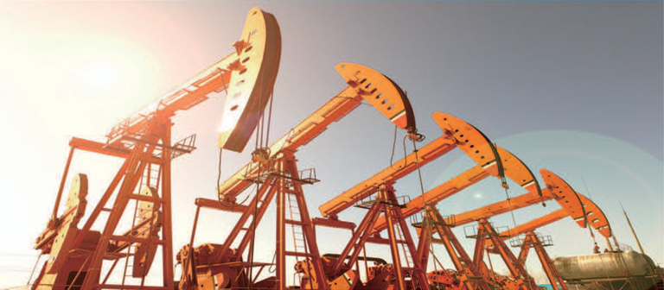

Photovoltaic Power Generation Group
GNEE Steel Group launched wind power generation-specific step-up equipment - wind power dedicated combined transformers, which have the advantages of low no-load loss, high insulation strength, no leakage, strong adaptability to outdoor environments, and less maintenance.

